CS 255 System Design Document Template

UML Diagrams

UML Use Case Diagram
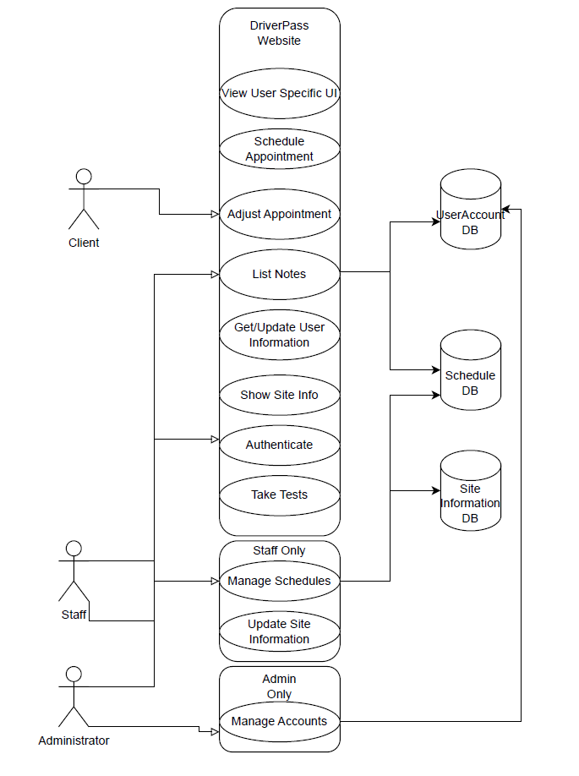

UML Activity Diagrams
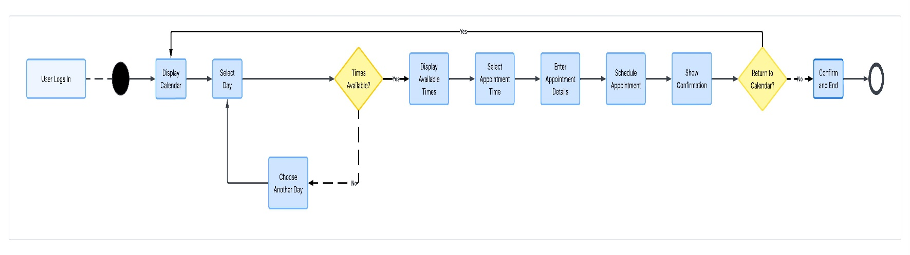
User Scheduling a Session Use Case
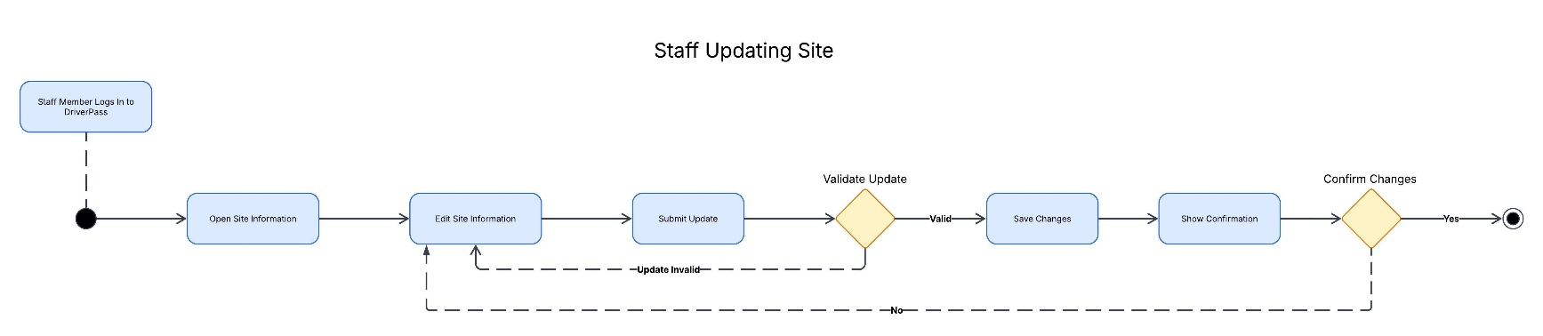
Staff Updating Site Use Case

UML Sequence Diagram
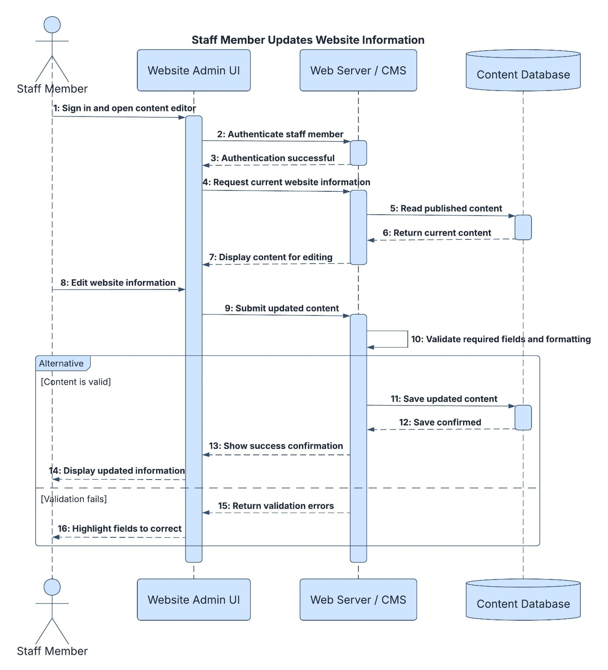

UML Class Diagram
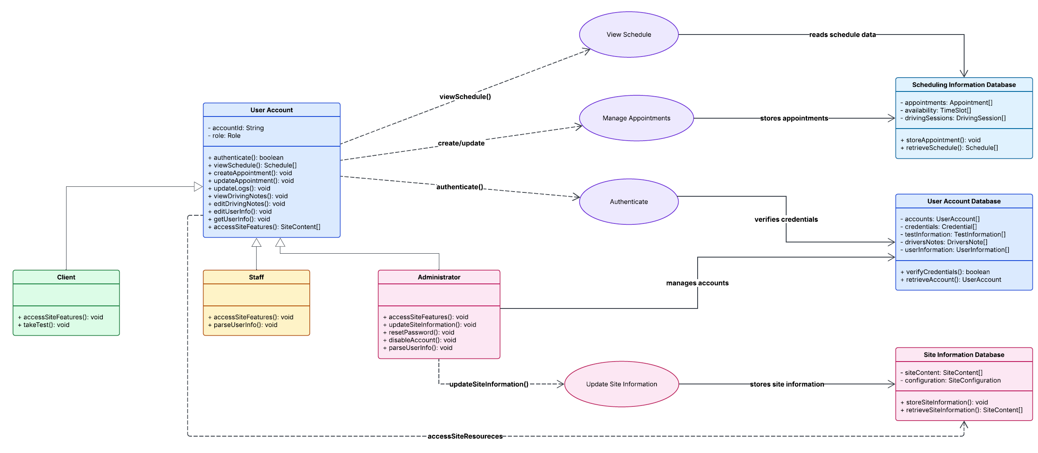

Technical Requirements
The technical requirements for the DriverPass system must cover general web server hosting, a notification system, and compatibility with multiple browsers to serve its function. The required software could be built in Java and use a backend SQL or similar database to track and manage the schedule. The hosting servers can run either Linux or Windows, as they are not dependent on either type, and the client can choose based on preference or experience. Access to the site can be done via a web browser to adjust content or manage accounts, similar to other websites. Tracking and maintaining notes and other features can also be handled via additional SQL databases or tables.

